Experiment No. 7: Text Processing Toolkit using String Methods and Regular Expression Patterns
- Software/Tools Required: VS Code, Web Browser, HTML, CSS, and JavaScript
- Theory: Strings in JavaScript are sequences of characters that can be transformed using built-in methods such as substring(), concat(), includes(), toUpperCase(), and trim(). Regular expressions define search patterns that describe character combinations, enabling operations like validation, searching, and substitution. Combining string methods with regex using match(), search(), test(), and replace() allows developers to build robust tools for email validation, data extraction, and text statistics.
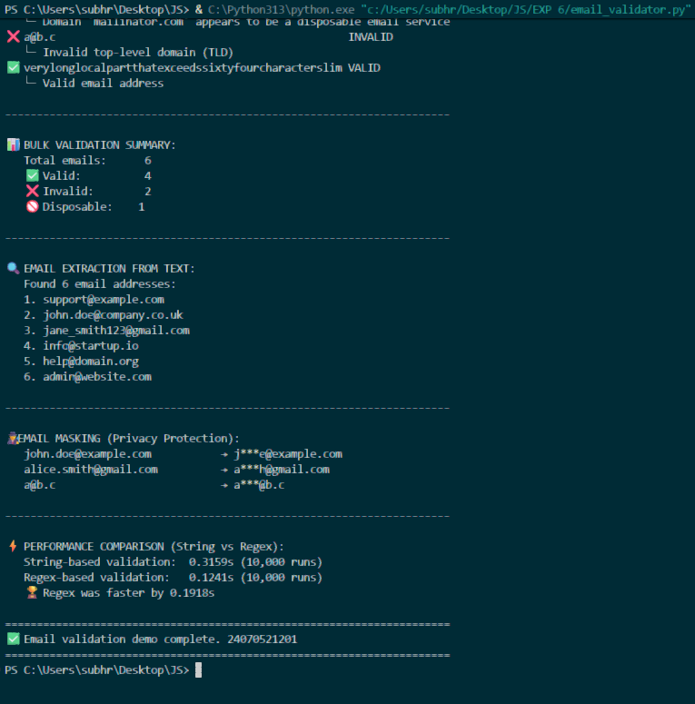

Result: The text processing toolkit was successfully developed using HTML, CSS, and JavaScript. The email validation module used a regex pattern to verify whether the entered email followed the standard format, displaying appropriate success or error messages. The data extraction module identified and extracted all email addresses and URLs from a sample paragraph using the global flag with match(). The text analysis module calculated the word count, character count, number of sentences, and frequency of specific keywords in the given text.
Conclusion: This experiment illustrates how string functions and regular expressions together form a powerful toolkit for text processing. Through this project, the working of string manipulation methods and regex quantifiers, character classes, and flags was practically understood. Email validation showcased input verification, while extraction and analysis demonstrated pattern-based searching. Overall, the experiment strengthened the understanding of text handling techniques widely used in real-world web development.

